For the line graph, I chose the average as the metric, and I think the rate of dealing with bugs is mostly concentrated in an interval.

For the V4.1:

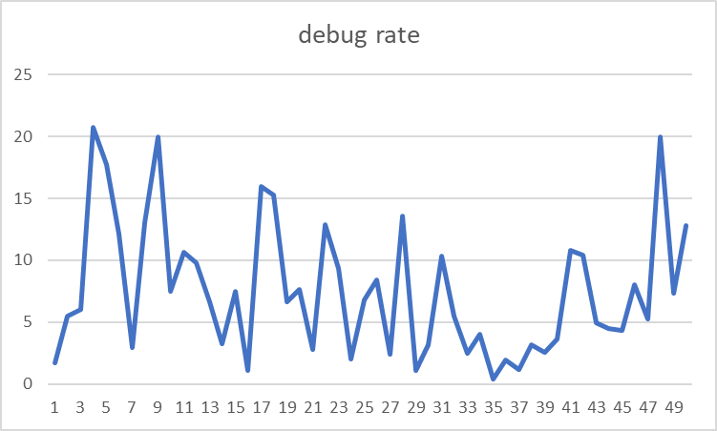

The average is 7.556, the rate of handling bugs is basically this

For the V4.4

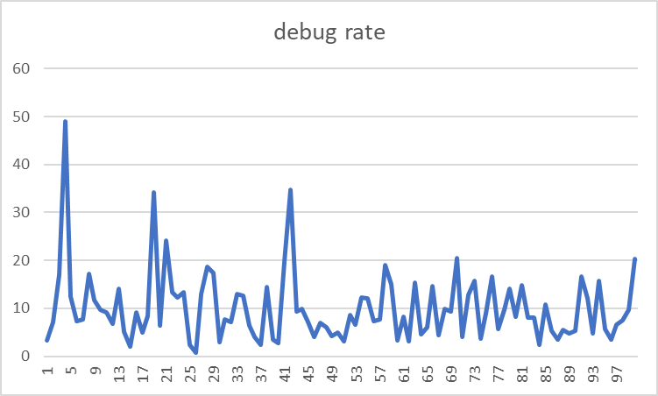

The average is 10.0312.

For the V4.9

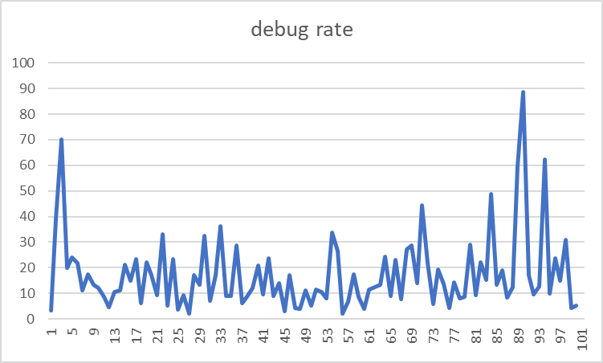

The average is 17.334.

For the v4.14

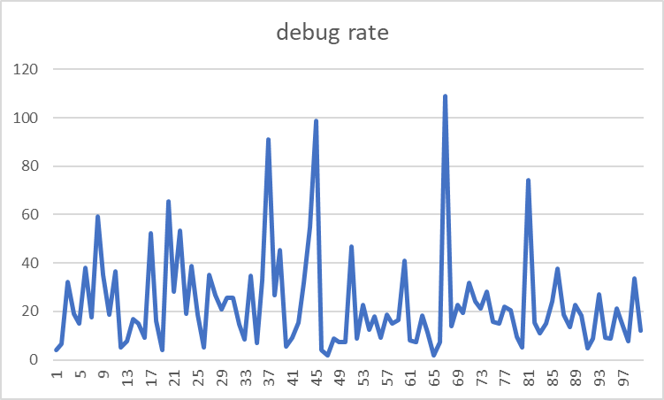

The average is 10.0312

For the v4.19

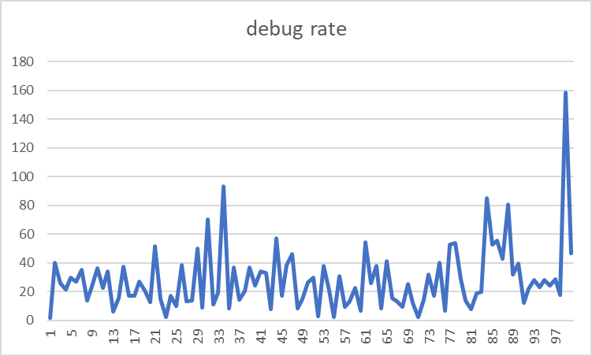

The average is 22.968.

Conclusion:

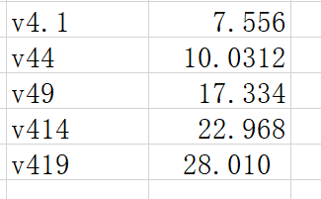

The data moves up and down around the value, and the value gradually increases